**About Hybris**

* SAP Hybris Commerce organizes data like product information to be propagated using multiple communication channels in a consistent and efficient way.
* This enables businesses to sell products across multiple distribution channels.
* SAP Hybris Commerce is a complete set of Hybris functionality from all areas.
* The Hybris product components, such as modules and extensions, are classified according to the following areas:

**Platform:** The Platform area consists of a standard set of extensions that provide the main functionality of a Hybris installation.

**Accelerators:** The Accelerators area provides a ready-to-use web framework that enables you to jumpstart your implementation and easily builds and maintains a feature-rich omni-channel commerce solution.

**Commerce:** The Commerce area enables management of channel neutral and channel specific business logic and processes.

**Orders:** The Orders area provides centralized management of orders that hides the complexity of the multi-channeled background of the ordering process.

**Product Content Management:** The Product Content Management area is a centralized repository of structured information, text, web content, print layouts, and more.

**Customer Experience:** SAP Hybris's Customer Experience is a next-generation web content solution that enables organizations to create even more relevant, personalized and exceptional experiences. It features Smart Edit, Personalization, and more.

**Channel:** The **Channel** area provides management of channel specific visualization and interaction.

**Integrations:** The **Integrations** area allows you to extend your Hybris to other solutions.

**FROM SINGLE-CHANNEL TO OMNICHANNEL**

* For selling products you commonly cover different distribution channels.
* Based on consistent single-source product information, multiple channels enable you to scale your sales activities.
* Even more, you can integrate and orchestrate your marketing activities across multiple channels.

**Single Channel**

* A single channel can be a unique communication channel, which is for information only, or a unique commerce channel through which goods, services, and information flow from vendor (or manufacturer, distributor) to consumer (or business customer, dealer, distributor).
* Such a transactional commerce channel, can be online (web site, electronic catalog) or offline (store, printed material).
* Hybris provides tools like for feeding information into channels and other tools for implementing the channels themselves, for example a web shop, a mobile shop, a print catalog, or an electronic catalog.

**Multi Channel**

* Multi channel is the concept of offering not just one communication or commerce channel to your consumers (or business customers, dealers) but multiple.
* In order to ensure consistent information like product information, pricing, or promotions in all channels, a single source of truth of product data is mandatory.
* This is achieved by a Product Information Management System (PIM) that tightly integrates with channel specific applications.
* SAP Hybris Commerce with its strong PIM component enables you to centrally manage product data.
* In addition, you easily can add channels like e-catalogs, Point of Sales (POS) kiosk systems, mobile web shops, or call center applications extending the options of SAP Hybris Commerce and Hybris Print.

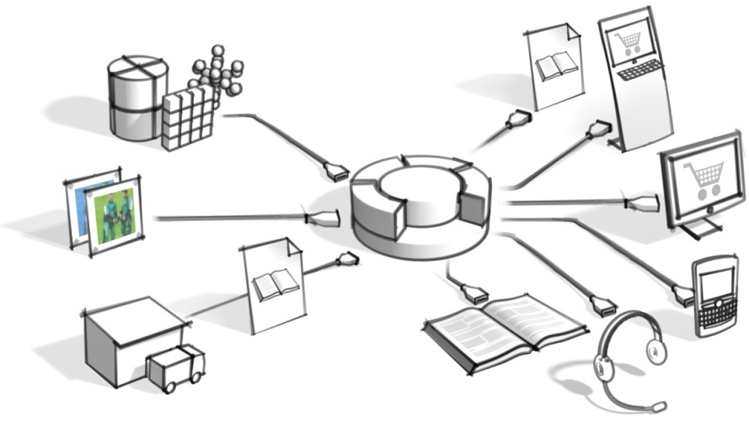

Figure: Schema of the SAP Hybris Commerce. The input channels are on the left, the output channels on the right.

## Cross Channel

* this would Based on a consistent multi-channel infrastructure, companies can start guiding customers pro-actively from one channel to the other by means of loyalty programs, store events, vouchers, gift cards, special channel specific promotions, and more.
* If a consistent multi-channel infrastructure is not in place only confuse customers, due to disparate and often conflicting product information, availability, and pricing information.

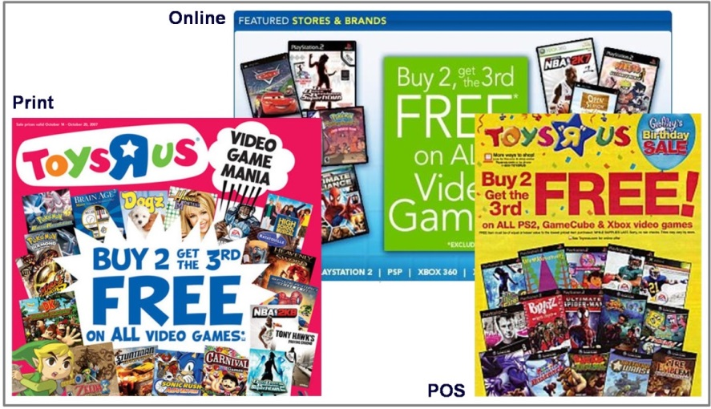

Figure: Cross-channel campaigns require consistent information not only about products but also about promotions.

* Customers tend to use all channels simultaneously.
* For example, having the printed catalog on their desk, a customer orders a product via web shop, that is picked up and paid for in a local retail shop.
* Such a cross-channel approach supports and reinforces the natural behavior of customers and consumers.

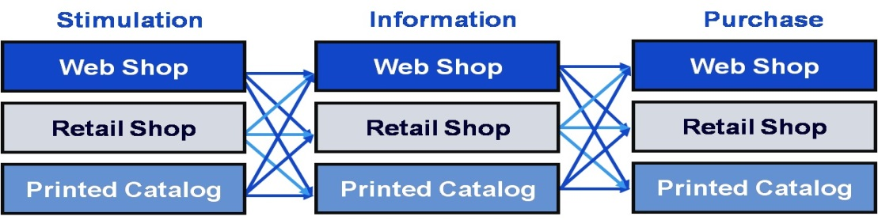

Figure: Cross-channel hopping customers tend to use use different channels (symbolized by horizontal layers) for stimulation, information, and purchase.

* Based on SAP Hybris Commerce, you can orchestrate your complementary or channel specific marketing activities, and thus leverage your business across all distribution channels.

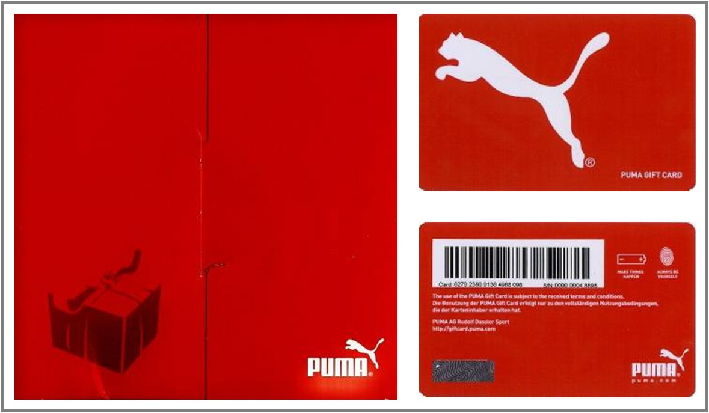

Figure: A sample gift voucher loaded online but valid in both online and offline channels.

## Omnichannel

* Physical and digital commerce are converging at an incredible pace—driven by highly connected customers who demand experiences that adapt to their mode of purchasing and shopping.
* This opens the door for a new imperative known as OmniCommerce, which favors a customer-centric approach over channel-specific processes.
* The number of customer touch points is exploding and innovation and agility are critical factors for business success.
* Today, you need to be able to seamlessly sell and communicate consistently across online stores, smart phones, tablets, social networks, and any Internet-enabled device.

Hybris allows for a pure omni channel customer experience. Our platform gives the customer a single view of the merchant across digital and physical commerce.

**PLATFORM**

* Hybris Platform consists of a standard set of extensions providing the main functionality of a Hybris installation.
* An extension is a group of features comprising a subset of SAP Hybris Commerce functionality.
* An extension can contain business logic, type definitions, a web application, and many other things.

**Core Concepts:**

1. [Architecture of SAP Hybris Commerce](https://help.hybris.com/6.0.0/hcd/8b555d0486691014bb59c1e835c53f8b.html)
2. [Extension Concept](https://help.hybris.com/6.0.0/hcd/8bbf0b9d866910149688b8d696c8d47e.html)
3. [Cockpit Framework](https://help.hybris.com/6.0.0/hcd/8b7eb27986691014a3568a4e74be4fc8.html)
4. [Product and Data Modeling](https://help.hybris.com/6.0.0/hcd/8c317a28866910149816b4a652470b16.html)
5. [Hybris Platform Search Mechanisms](https://help.hybris.com/6.0.0/hcd/8be9f4e586691014b318d62074b74ab5.html)
6. [Internationalization and Localization](https://help.hybris.com/6.0.0/hcd/8bfc4c3c8669101493d9a2d97afcc5df.html)
7. [Media](https://help.hybris.com/6.0.0/hcd/8c0fbaf186691014b1389bc475fb7b02.html)
8. [Security and Users Management](https://help.hybris.com/6.0.0/hcd/8c5896be86691014afb19ff3320d73be.html)

## Essential Features

1. [Administration in SAP Hybris Commerce](https://help.hybris.com/6.0.0/hcd/8b4e446786691014b4539d60054d4898.html)
2. [Hybris Platform Web Services](https://help.hybris.com/6.0.0/hcd/8bea21ae86691014ba63caf92420bcf6.html)
3. [Ordering, Payment and Pricing Standards in the Hybris Platform](https://help.hybris.com/6.0.0/hcd/8b3b38dd86691014ac9b85cc0c8637bb.html)
4. [Processing in SAP Hybris Commerce](https://help.hybris.com/6.0.0/hcd/8c314fc1866910148c3ce11aef933f54.html)
5. [Reporting](https://help.hybris.com/6.0.0/hcd/8c3d5ef386691014b1d4e1d9f283cfe1.html)
6. [Data Validation](https://help.hybris.com/6.0.0/hcd/8ba81fc286691014a111ee7a527abf72.html)

## Technical Topics

1. [Building SAP Hybris Commerce](https://help.hybris.com/6.0.0/hcd/8b6e6adb86691014abf3fa1d3e37c3ef.html)
2. [SAP Hybris Commerce in a Cluster](https://help.hybris.com/6.0.0/hcd/8be81dcb86691014af64fa24e2b390b1.html)
3. [Application Performance and Monitoring](https://help.hybris.com/6.0.0/hcd/8b54a65386691014baa8fea5134a62ba.html)
4. [Testing](https://help.hybris.com/6.0.0/hcd/8c6f059d866910149b6aede7ab7a0f36.html)
5. [Logging](https://help.hybris.com/6.0.0/hcd/8c07853c866910148a00baf81ea1669e.html)

# ARCHITECTURE OF SAP HYBRIS COMMERCE

* The architecture of SAP Hybris Commerce is flexible and modular.
* At its foundation is Hybris Platform consisting of core functionality upon which all other functionality is built.
* An understanding of the various layers is essential to customizing the solution.
* To familiarize yourself with the whole architecture, first of all you need to understand its basic concept and layer approach to architecture.
* Then you can dig deeper into the topic of Service Layer and how it works together with the Spring framework.
* Then you should learn about more technical topics like caching, filtering solution, multitenancy, and possibly how to keep track of attributes changes.

# ARCHITECTURE OVERVIEW

* SAP Hybris Commerce is highly flexible and modular software.
* This flexibility comes from several layers of abstraction and modularized functionality.

## Basic Architecture

1. From a business point of view, SAP Hybris Commerce is divided into individual packages, such as Commerce, Content, Channel, and Orders.
2. These packages are bundles of features assembled for a certain range of business functionality.
3. All of these packages rely on more basic functionality provided by the Hybris Platform.
4. While the Hybris Platform can run without any package, no package can run without the Hybris Platform.

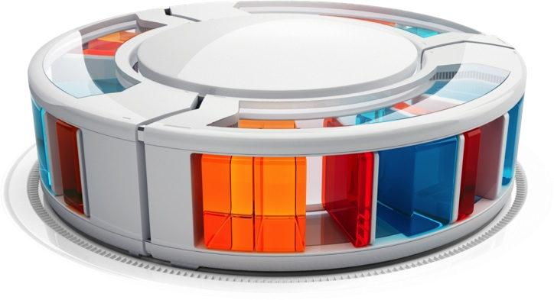

1. From a more technical point of view, packages consist of individual modules (also referred to as[extensions](https://help.hybris.com/6.0.0/hcd/8b49cab88669101489be9ac91a5f1ebb.html) ).
2. For example, the Hybris Print technically consists of two extensions: **Print** (the technical foundation) and **Print Cockpit** (the graphical user interface).
3. Extensions are written by Hybris or the implementation partner of your project.
4. Extensions written by Hybris provide standardized functionality and are supported and maintained by Hybris.
5. If you write an extension, you need to maintain them by yourself, but you are free to implement any business functionality you need.
6. A full SAP Hybris Commerce installation therefore consists of the Hybris Platform plus any Hybris packages plus any additional extensions that you have implemented.
7. Extensions that are part of Hybris Platform proper are also referred to as the core extensions.
8. On top of these core extensions, Platform contains several pieces of Hybris software, such as the [Build Framework](https://help.hybris.com/6.0.0/hcd/8b6ded0d86691014a6fab18e171c1f91.html), and third-party software, such as the pre-bundled Apache Tomcat.
9. SAP Hybris Commerce is run in a Java Virtual Machine on a Servlet Container or a J2EE-compliant application server (such as Oracle WebLogic) and connects to an external database (MySQL, Oracle DB, Microsoft SQL Server).
10. Internal caching and persistence mechanisms allow SAP Hybris Commerce to run on a Servlet Container.
11. A full-fledged J2EE-compliant application server can be used but is not necessary.

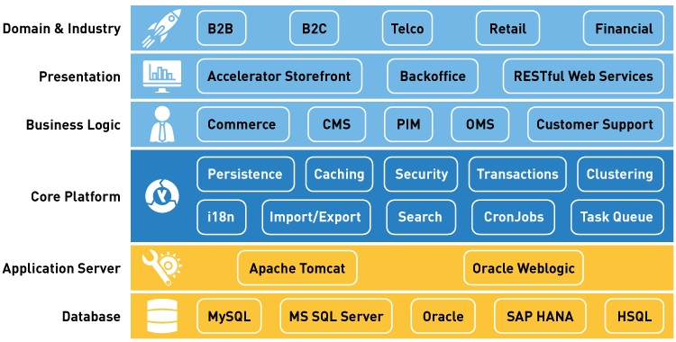

***Figure 1: A view of the various features of an SAP Hybris Commerce installation.***

1. The Platform layer abstracts data from the storage structure on the database using the persistence framework and provides functionality such as [Clustering](https://help.hybris.com/6.0.0/hcd/8b7c5c75866910148c329ee71f3a681e.html) and the [Hybris Platform Cache](https://help.hybris.com/6.0.0/hcd/8be98ee4866910149df8be0aab4d0b62.html" \o "The Hybris Cache is a part of the Hybris persistence layer. It improves the performance of a single server node by reducing the amount of database queries. It transparently stores search results, item attributes, and item instances in memory.).
2. Relying on the persistence framework, the other functional components of the Platform Layer provide basic business functionality: [Transactions](https://help.hybris.com/6.0.0/hcd/8c7387f186691014922080f2e053216a.html), [CronJobs](https://help.hybris.com/6.0.0/hcd/8b9ce4868669101499b2f0f25ef9395f.html), [Personalization](https://help.hybris.com/6.0.0/hcd/8c428f8286691014970ceee87aa01605.html), [Internationalization](https://help.hybris.com/6.0.0/hcd/8bfc204086691014a345f64b08505839.html), and more.
3. The packages on the Functional Layer (SAP Hybris Commerce, Hybris PIM, Hybris Print) use Platformto implement the functions they deliver. Actually, Hybris Platform is part of any Hybris Package.

## Layer Architecture

SAP Hybris Commerce contains several layers, each of which has a different function and data abstraction level.

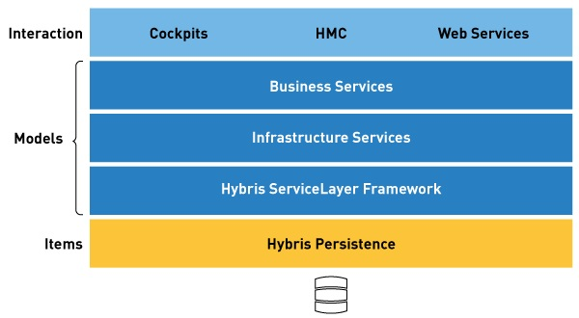

***Figure 2: Overview of the abstract layers of SAP Hybris Commerce.***

| **Layer Name** | **Description** | **What would a Product look like on this Layer?** |
| --- | --- | --- |
| Cockpits, HMC, WebServices | 1. This is where objects are represented in a way that an end-user can interact with them: add products to a cart, edit a product description, or set a password for a user account, for example. 2. On this layer it is possible to let a user do something with an object in theHybris Platform via a graphical user interface. 3. Functionality on this level (such as the JSF-based HybrisStoreFoundation or the ZK-basedHybris Print Cockpit) uses the ServiceLayer for functionality and the Type Layer for storage of objects. 4. Depending on the complexity of your implementation, this layer can itself consist of several individual layers and even use an individual data model |  |
| ServiceLayer Framework  (including the actual ServiceLayer, the Infrastructure Services, and the Business Services) | 1. Provides the Java Application Programmer's Interface (API) for objects in SAP Hybris Commerce, the Hybris API. 2. The HybrisServiceLayer relies on so-called models, which are POJO objects. 3. Attributes on models have automatically generated getter and setter methods. 4. Models are generated based on types. | **ProductModel.java**  **public** **class** ProductModel **extends** ItemModel  {  /** <i>Generated constant</i> - Attribute key of <code>Product.catalogVersion</code>  * attribute defined at extension <code>catalog</code>. */  **private** **static** **final** String CATALOGVERSION = "catalogVersion";    /** <i>Generated constant</i> - Attribute key of <code>Product.code</code>  * attribute defined at extension <code>core</code>. */  **private** **static** **final** String CODE = "code";    * <i>Generated method</i> - Getter of the <code>Product.catalogVersion</code>  * attribute **defined** at extension <code>catalog</core>.  * @return the catalogVersion  */  **public** CatalogVersionModel getCatalogVersion()  {  **if**( !isAttributeLoaded(CATALOGVERSION))  {  **this**._catalogVersion = (CatalogVersionModel)  loadAttribute(CATALOGVERSION);  }  **return** **this**._catalogVersion;  }    /**  * <i>Generated method</i> - Getter of the <code>Product.code</code>  * attribute defined at extension <code>core</core>.  * @return the code  */  **public** String getCode()  {  **return** _code;  } |
| [Type Layer](https://help.hybris.com/6.0.0/hcd/8c755da8866910149c27ec908fc577ef.html) | 1. Describes business object models. 2. It is on this layer that definitions of business objects (types) and their fields (attributes) are made via theitems.xml (see [items.xml](https://help.hybris.com/6.0.0/hcd/8bffa9cc86691014bb70ac2d012708bc.html)) file. 3. Models are generated based on types. | **items.xml**  <itemtype code="Product" extends="LocalizableItem">  <attributes>  <attribute qualifier="code" type="java.lang.String"/>  </attributes>  </itemtype> |
| Persistence Layer | 1. Deals with abstraction from the database, caching, and clustering. 2. You are not likely to get into contact with the Persistence Layer at all as it is completely transparent and does not require any explicit interaction from your side. | SQL-compliant representation of numbers and strings in a database table, such as [VARCHAR](http://help.sap.com/disclaimer?site=http://en.wikipedia.org/wiki/Varchar), [CLOB](http://help.sap.com/disclaimer?site=http://en.wikipedia.org/wiki/Clob) |
| Database | 1. Although not a layer of SAP Hybris Commerce, the database is also an important component in this overview: the database makes the data held in SAP Hybris Commercepersistent. | Database-specific representation of numbers and strings. |

## Modes of Operation

You can run SAP Hybris Commerce in three different modes of operation:

